COMPLETE_Experimental_Data_Analysis

PSYC300

## The Paper

Kampfer, K., Leischnig, A., Ivens, B. S., & Spence, C. (2017). Touch-flavor transference: Assessing the effect of packaging weight on gustatory evaluations, desire for food and beverages, and willingness to pay. *PloS one*, 12(10), e0186121.

Companies influence consumers in subtle ways when trying to persuade them to purchase a product. Things like package shape, material, use of color, and font can change consumer perception of a product’s quality. One such factor is package weight. These researchers proposed that the weight of a package would influence how willing one would be to purchase that product.

Participants were measured on a battery of constructs including perceptions of flavor, willingness to purchase, biological sex, and age. These data are a subset of the original data collected in the study. The analyses we do will not necessarily emulate the ones in the paper.

Understanding potential reasons why one may purchase a product can empower consumers to not fall for tricks that manufacturers play like package weight.

## The Variables

**WEIGHT:** Whether the participates ate chocolate from a weighted (2) wrapper or not (1).

**FLAV_INT:** A self-report measure of the perceived flavor intensity of the chocolate. One item on a scale of 1-7.

**PURCHASE:** An open-ended question coded on a scale of 1-10, where larger values indicate a greater willingness to purchase the product.

**SEX:** The participant’s biological sex (1 = Male, 2 = Female).

**AGE:** The participant’s age (standardized).

For all constructs, higher values = greater levels of construct.

## The Analysis

We are going to fit a model to the data with their experimental group (heavy/light wrapper; WEIGHT) as the predictor and their purchasing likelihood as the outcome (MCIVIL).

### Load the Required Packages

We need to read in **ggplot2** and **jtools**.

library(ggplot2) # for data visualization  
library(jtools) # for APA formatting in figures

### Read in the Data

If you’re working on Jupyter, this is in the same folder as the file so you won’t need the file path.

# read data into an object called choc  
choc <- read.csv(file = "~/PSYC300-SP25/Lectures/Experimental Research/chocolate_data.csv")  
# replace first variable name with "weight" to remove X...  
names(choc)[1] <- "weight"

### Generate Descriptive Statistics

Use the summary command.

# generate summary statistics of all variables  
summary(choc)

weight flav_int purchase sex   
 Min. :1.000 Min. :1.000 Min. : 0.000 Min. :1.000   
 1st Qu.:1.000 1st Qu.:4.000 1st Qu.: 0.800 1st Qu.:1.000   
 Median :1.000 Median :5.000 Median : 1.950 Median :2.000   
 Mean :1.453 Mean :4.626 Mean : 2.569 Mean :1.561   
 3rd Qu.:2.000 3rd Qu.:6.000 3rd Qu.: 3.970 3rd Qu.:2.000   
 Max. :2.000 Max. :7.000 Max. :10.000 Max. :2.000   
 age   
 Min. :17.00   
 1st Qu.:21.00   
 Median :23.00   
 Mean :22.96   
 3rd Qu.:24.00   
 Max. :36.00

# look at breakdown of groups  
table(choc$weight)

1 2   
76 63

### Visualize the Data

What visualization would be appropriate for a dichotomous predictor and continuous outcome?

**Answer:** Boxplot

# plot weight condition by purchasing intent   
ggplot(data = choc, aes(x = as.factor(weight), y = purchase)) +  
 geom_boxplot() +   
 labs(x = "Condition (1 = Unweighted Wrapper, 2 = Weighted Wrapper", y = "Purchasing Intent") +   
 jtools::theme_apa() # make APA formatting

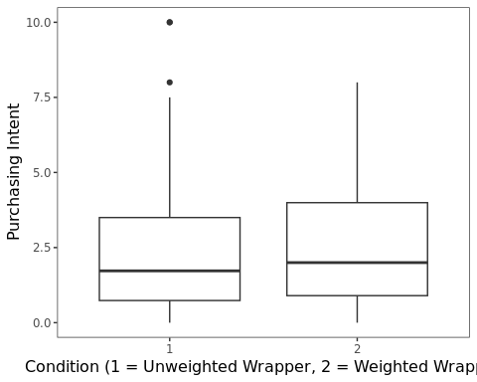

How do the assumptions look?

* Linearity: Assumption of linearity seems reasonable.
* Homogeneity of variance: The assumption of homogeneity of variance appears reasonable.
* Normality of residuals: If you want, you can check this in the “Model” section using the command hist(resid(model_name))

### Fit the Model to the Data

What test should you run? (Note: The command in R is the same.)

**Answer:** Independent groups *t*-test

# run the analysis between the weight and purchase variables  
# you need var.equal=TRUE or else it will pool the variances, which will do a different test than the normal-theory one we are accustomed to  
# as.factor() around the weight variable let's R know to treat the weight condition as a categorical factor (which it is)  
t.test(choc$purchase ~ as.factor(choc$weight), var.equal= TRUE)

Two Sample t-test  
  
data: choc$purchase by as.factor(choc$weight)  
t = -0.34633, df = 137, p-value = 0.7296  
alternative hypothesis: true difference in means between group 1 and group 2 is not equal to 0  
95 percent confidence interval:  
 -0.8956358 0.6286684  
sample estimates:  
mean in group 1 mean in group 2   
 2.508421 2.641905

# this won't work because it will treat each variable as a vector to compare the means of  
#t.test(choc$purchase, choc$weight)

What are the results? Try in APA format.

**Answer:** The difference in purchasing likelihood between the two groups was not statistically significant, *t*(137) = -0.35, *p* = .73.

### Exploratory Data Analysis

Run the code below if you want to explore the relationship between other variables in the dataset. You can also test out other relationships you’re interested in! (Or just ignore; the code below will render just fine.)

# plot weight condition by flavor intensity  
ggplot(data = choc, aes(x = as.factor(weight), y = flav_int)) +  
 geom_boxplot() +   
 labs(x = "Weight", y = "Flavor Intensity") +   
 jtools::theme_apa()

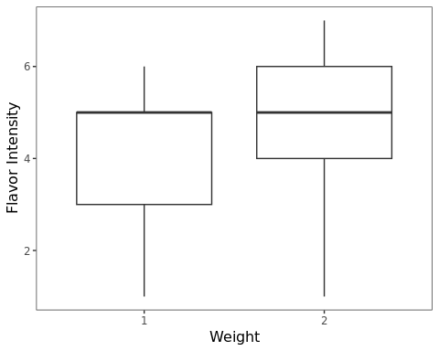

# there appears to be an effect here  
  
# run t-test to see if the apparent difference is significant  
# as.factor() lets R know to treat the weight variable as a categorical factor (which it is)  
t.test(choc$flav_int ~ as.factor(choc$weight), var.equal=TRUE)

Two Sample t-test  
  
data: choc$flav_int by as.factor(choc$weight)  
t = -3.156, df = 137, p-value = 0.001967  
alternative hypothesis: true difference in means between group 1 and group 2 is not equal to 0  
95 percent confidence interval:  
 -1.1601320 -0.2663508  
sample estimates:  
mean in group 1 mean in group 2   
 4.302632 5.015873

# those in the heavier wrapper condition perceived the flavor to be more intense!  
  
# plot perceived flavor intensity by purchasing intent  
ggplot(data = choc, aes(x = flav_int, y = purchase)) +  
 geom_point() +   
 labs(x = "Flavor Intensity", y = "Purchasing Intent") +   
 jtools::theme_apa()

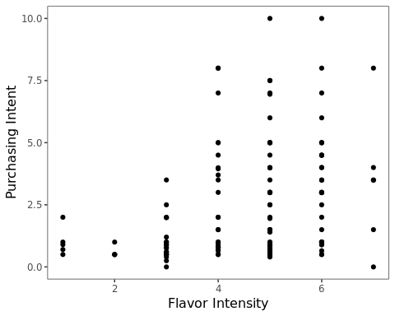

# there appears to be a significant, positive association here  
  
# test correlation between flavor intensity and purchasing likelihood  
cor.test(choc$purchase, choc$flav_int)

Pearson's product-moment correlation  
  
data: choc$purchase and choc$flav_int  
t = 4.0585, df = 137, p-value = 8.26e-05  
alternative hypothesis: true correlation is not equal to 0  
95 percent confidence interval:  
 0.1703983 0.4685477  
sample estimates:  
 cor   
0.3276045

# the correlation was significant!

Although there was no difference between the two wrapper weight conditions in their intent to purchase the product, the weight of the wrapper affected the perceived intensity of the flavor of the chocolate, which in-turn increased the likelihood of purchasing the chocolate. This is the idea of an indirect effect, which we will cover in more detail in two lectures.

## End of script